Project Design Phase-I

# Problem — Solution Fit Template

|  |  |
| --- | --- |
| Date | 10 Nov 2022 |
| Team ID | PNT2022TMID29189 |
| Project Name | Project - Real-Time Communication System Powered by AI for Specially Abled |
| Maximum Marks | 2 Marks |

Problem — Solution Fit Template:

The Problem-Solution Fit simply means that you have found a problem with your customer and that the solution you have realized for it actually solves the customer's problem. It helps entrepreneurs, marketers and corporate innovators identify behavioral patterns and recognize what would work and why

Purpose:

Solve complex problems in a way that fits the state of your customers.

Succeed faster and increase your solution adoption by tapping into existing mediums and channels of behavior.

Sharpen your communication and marketing strategy with the right triggers and messaging. Increase touch-points with your company by finding the right problem-behavior fit and building trust by solving frequent annoyances, or urgent or costly problems.

Understand the existing situation in order to improve it for your target group.

# Template:

deafness (Hearing loss).

For inability to speak and see(muteness.) those prople who face di8iculty to communicate with normal people through sign language

Communication bei•een aqeciatly-abled and ordinary



recognizing w‹xds or sentences using sign

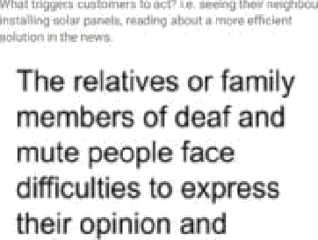

communicating with

them.

Being leR out of social activities.

Oeaf end mute people just ahare the information through eign language and Ouse gestures ale made using hands, fingers, arms, heed, and alao facial expreasioua.

We tske a **seleaed** problem **and give a soltXion. That soluton is extremely helpful for paopie who face difficulty**



Hearing disaNlttia6 and Speaking problems are



iuds.

The recognition of aigne wtth iédal expression, hand

simultaneously with better racognftton accuracy in real-time with improved perlbrmanoa helps in bettar co‹nmunlcation.

A study on-manual aign



leas eyebrow rroven›ent, and rn‹Mh shape, This can be vacea and interpreted to ahow axTtmunication.





We then build a LSTM model and train with our etored data which trips us io datect ac0on with a number of fremes.

Droe Gaining is done, we can use thia modal for real time hand ge9lure detection and simuhaneously convert the gesture \o speecn uaing OpenCV.

